P530/2

**BIOLOGY PAPER 2**

JUNE 2019

21/2 hours

RESOURCE EXAMINATIONS 2019

**UGANDA ADVANCED CERTIFICATE OF EDUCATION**

BIOLOGY PAPER 2

2 hours 30 minutes.

**INSTRUCTIONS TO CANDIDATES:**

*Answer question one in section A plus three others from section* ***B****.*

*Candidates are advised to read the questions carefully, organize their answers and present them precisely and logically, illustrating with well labeled diagrams where ever necessary.*

*Write on the answer sheet, your name, index number and the questions attempted in their order as shown in the table.*

|  |  |
| --- | --- |
| **Question** | **Marks** |
|  |  |
|  |  |
|  |  |
|  |  |
| **Total** |  |

**SECTION A**

**1**.A yeast culture, containing initially 18000 cells cm-3 and supply of glucose was set up in a laboratory fermenter and maintained in a constant optimum temperature of 35oC in water bath. The glucose concentration, ethanol concentration and pH were monitored over 24 hours period. The number of yeast cells was estimated at intervals during the experiment. The results obtained are shown in the graph below.

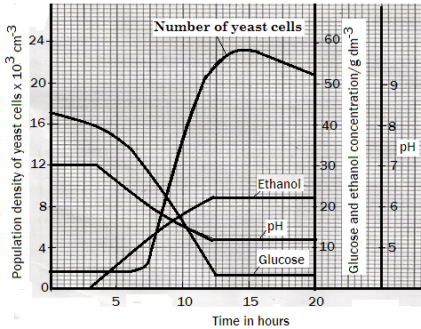

1. Calculate,
2. Rate of increase in population density of the yeast cells. (03 marks)
3. Percentage of glucose which had been used by the yeast by the end of the experiment. (02 marks)
4. Compare Glucose and Ethanol concentrations. (06 marks)
5. Explain,
6. Relationship between the variation in population density of the yeast cells and the glucose concentration over 20 hours’ period. (14 marks)
7. Changes in the ethanol concentration. (06 marks)
8. pH levels at the beginning and at the end of the experiment. (04 mks)

(d) Predict the changes that will take place in the population density of the yeast cells if the experiment had continued beyond the 20 hours period and give reasons for your answer. (02 marks)

(e) State any three importance of yeast cells in an ecosystem. (03 marks)

**SECTION B (60 MARKS)**

**2**. (a) Compare Respiration and photorespiration. (10 marks)

(b) Explain how the respiratory compound lipid enters Krebs cycle in the cells

of living organism. (10 marks)

**3**. (a) Describe the interactions of various species of organisms in an Ecosystem.

(09 marks)

(b) Explain the sequence of changes that occurs in a previously burnt piece

of land from its initial stages until a climax community. (11 marks)

**4** (a) What is meant by the term “mass flow”. (02 marks)

(b) Compare the translocation of materials in xylem vessels and that which

takes place in sieve tubes of flowering plants. (08 marks)

1. Explain mechanisms by which sugars actively transported through the

sieve tube. (10 marks)

**5** (a) Describe advantages and disadvantages of both internal and external

fertilization in animals. (11 marks)

(b) Explain series of events that occur in the oviduct which leads to fertilization

in mammals. (09 marks)

**6** (a) Describe the structure of transfer Ribonucleic Acid. (07 marks)

(b) Compare DNA replication and transcription. (09 marks)

(c) Give evidences that support DNA control of protein synthesis. (04 marks)

**END**